Пензенский государственный университет

Кафедра «Вычислительная техника»

**ОТЧЕТ**

по лабораторной работе №2

по курсу «Разработка кроссплатформенных приложений»

на тему «Работа с коллекциями объектов»

**Выполнили студенты группы 20ВВВ1:**

Бектемирова А.Э.

Будников М.С.

**Приняли:**

Юрова О.В.

Карамышева Н.С.

Пенза 2023 г.

**Цель работы:** изучить библиотеку стандартных коллекций Java Collections Framework, позволяющую хранить различные структуры данных.

**Задание:**

|  |  |
| --- | --- |
| Номер варианта | Функция |
| 2 |  |

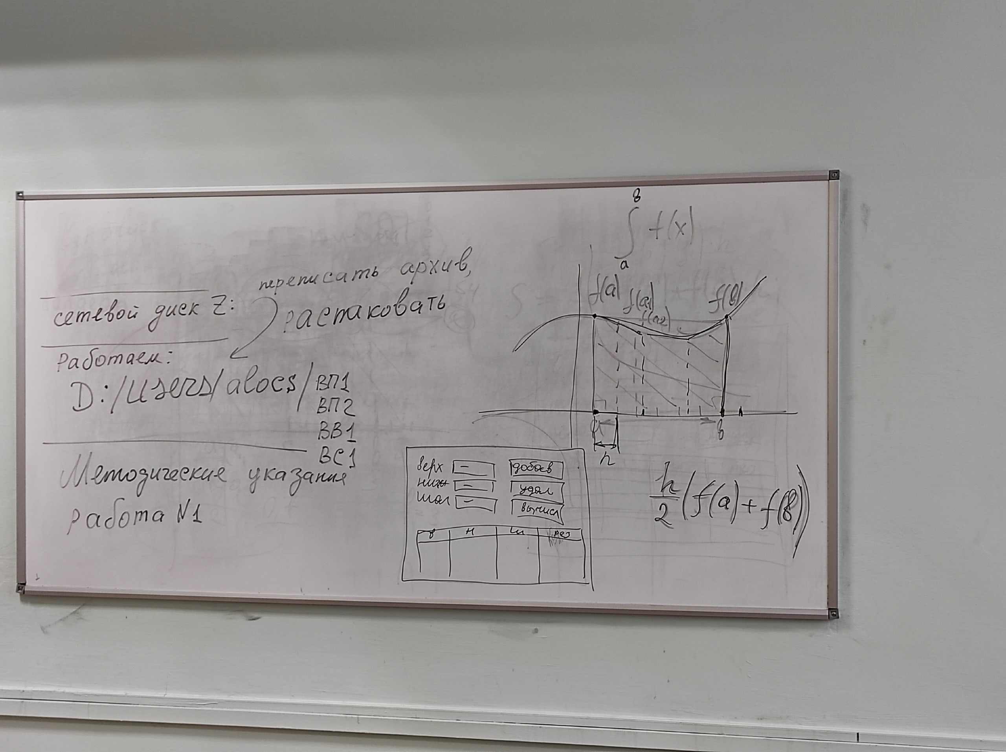

Модифицировать приложение из предыдущей лабораторной работы, реализовав хранение данных таблицы с использованием библиотеки коллекций. Для этого реализовать класс RecIntegral, способный хранить одну запись таблицы. Для нечетных вариантов в качестве класса-коллекции выбрать ArrayList, для четных - LinkedList. Кроме того, добавить пару кнопок: очистить / заполнить, которые будут очищать таблицу и заполнять ее данными из коллекции соответственно. Оформление лабораторной работы должно быть выполнено в соответствии с требованиями, приведенными в Приложении 2.

**Ход работы:**

1. Дополнили интерфейс приложения разработанного в предыдущей лабораторной работе двумя новыми кнопками.

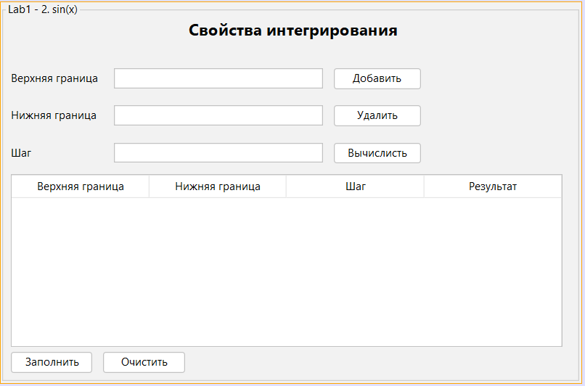

1. Прописали новые функции, выполняемые кнопками

Добавить

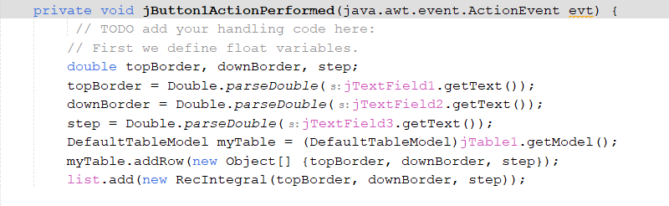

Заполнить

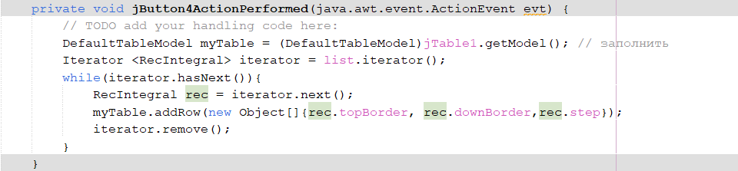

Очистить

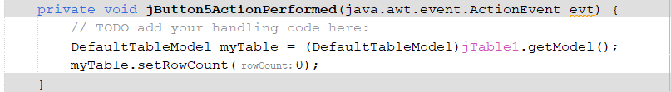

**Листинг:**

**RecIntegral.java**

/*

* Click nbfs://nbhost/SystemFileSystem/Templates/Licenses/license-default.txt to change this license

* Click nbfs://nbhost/SystemFileSystem/Templates/Classes/Class.java to edit this template

*/

package my.numberaddition;

/**

*

* @author Acer

*/

public class RecIntegral {

public double topBorder;

public double downBorder;

public double step;

public RecIntegral(double topBorder,double downBorder,double step){

this.topBorder = topBorder;

this.downBorder = downBorder;

this.step = step;

}

}

**ContactEditorUI.java**

/*

* Click nbfs://nbhost/SystemFileSystem/Templates/Licenses/license-default.txt to change this license

* Click nbfs://nbhost/SystemFileSystem/Templates/GUIForms/JFrame.java to edit this template

*/

package my.numberaddition;

import javax.swing.table.DefaultTableModel;

import java.util.LinkedList;

import java.util.List;

import java.util.Iterator;

/**

*

* @author Acer

*/

public class ContactEditorUI extends javax.swing.JFrame {

List<RecIntegral> list = new LinkedList<>();

/**

* Creates new form ContactEditorUI

*/

public ContactEditorUI() {

initComponents();

}

/**

* This method is called from within the constructor to initialize the form.

* WARNING: Do NOT modify this code. The content of this method is always

* regenerated by the Form Editor.

*/

@SuppressWarnings("unchecked")

// <editor-fold defaultstate="collapsed" desc="Generated Code">

private void initComponents() {

jPanel1 = new javax.swing.JPanel();

jLabel1 = new javax.swing.JLabel();

jLabel2 = new javax.swing.JLabel();

jLabel3 = new javax.swing.JLabel();

jButton1 = new javax.swing.JButton();

jButton2 = new javax.swing.JButton();

jButton3 = new javax.swing.JButton();

jTextField1 = new javax.swing.JTextField();

jTextField2 = new javax.swing.JTextField();

jTextField3 = new javax.swing.JTextField();

jScrollPane1 = new javax.swing.JScrollPane();

jTable1 = new javax.swing.JTable();

jLabel4 = new javax.swing.JLabel();

jButton4 = new javax.swing.JButton();

jButton5 = new javax.swing.JButton();

setDefaultCloseOperation(javax.swing.WindowConstants.EXIT_ON_CLOSE);

jPanel1.setBorder(javax.swing.BorderFactory.createTitledBorder("Lab1 - 2. sin(x)"));

jLabel1.setText("Верхняя граница");

jLabel2.setText("Нижняя граница");

jLabel3.setText("Шаг");

jButton1.setText("Добавить");

jButton1.addActionListener(new java.awt.event.ActionListener() {

public void actionPerformed(java.awt.event.ActionEvent evt) {

jButton1ActionPerformed(evt);

}

});

jButton2.setText("Удалить");

jButton2.setToolTipText("");

jButton2.addActionListener(new java.awt.event.ActionListener() {

public void actionPerformed(java.awt.event.ActionEvent evt) {

jButton2ActionPerformed(evt);

}

});

jButton3.setText("Вычислисть");

jButton3.addActionListener(new java.awt.event.ActionListener() {

public void actionPerformed(java.awt.event.ActionEvent evt) {

jButton3ActionPerformed(evt);

}

});

jTextField1.addActionListener(new java.awt.event.ActionListener() {

public void actionPerformed(java.awt.event.ActionEvent evt) {

jTextField1ActionPerformed(evt);

}

});

jTable1.setModel(new javax.swing.table.DefaultTableModel(

new Object [][] {

},

new String [] {

"Верхняя граница", "Нижняя граница", "Шаг", "Результат"

}

));

jScrollPane1.setViewportView(jTable1);

jLabel4.setFont(new java.awt.Font("Segoe UI", 1, 18)); // NOI18N

jLabel4.setText("Свойства интегрирования");

jButton4.setText("Заполнить");

jButton4.setPreferredSize(new java.awt.Dimension(90, 23));

jButton4.addActionListener(new java.awt.event.ActionListener() {

public void actionPerformed(java.awt.event.ActionEvent evt) {

jButton4ActionPerformed(evt);

}

});

jButton5.setText("Очистить");

jButton5.setPreferredSize(new java.awt.Dimension(90, 23));

jButton5.addActionListener(new java.awt.event.ActionListener() {

public void actionPerformed(java.awt.event.ActionEvent evt) {

jButton5ActionPerformed(evt);

}

});

javax.swing.GroupLayout jPanel1Layout = new javax.swing.GroupLayout(jPanel1);

jPanel1.setLayout(jPanel1Layout);

jPanel1Layout.setHorizontalGroup(

jPanel1Layout.createParallelGroup(javax.swing.GroupLayout.Alignment.LEADING)

.addGroup(jPanel1Layout.createSequentialGroup()

.addGroup(jPanel1Layout.createParallelGroup(javax.swing.GroupLayout.Alignment.LEADING)

.addGroup(jPanel1Layout.createSequentialGroup()

.addGap(6, 6, 6)

.addGroup(jPanel1Layout.createParallelGroup(javax.swing.GroupLayout.Alignment.LEADING)

.addComponent(jScrollPane1, javax.swing.GroupLayout.PREFERRED_SIZE, 608, javax.swing.GroupLayout.PREFERRED_SIZE)

.addGroup(jPanel1Layout.createSequentialGroup()

.addGroup(jPanel1Layout.createParallelGroup(javax.swing.GroupLayout.Alignment.TRAILING, false)

.addComponent(jLabel3, javax.swing.GroupLayout.DEFAULT_SIZE, javax.swing.GroupLayout.DEFAULT_SIZE, Short.MAX_VALUE)

.addComponent(jLabel2, javax.swing.GroupLayout.DEFAULT_SIZE, javax.swing.GroupLayout.DEFAULT_SIZE, Short.MAX_VALUE)

.addComponent(jLabel1, javax.swing.GroupLayout.DEFAULT_SIZE, javax.swing.GroupLayout.DEFAULT_SIZE, Short.MAX_VALUE))

.addGap(18, 18, 18)

.addGroup(jPanel1Layout.createParallelGroup(javax.swing.GroupLayout.Alignment.LEADING)

.addComponent(jTextField1, javax.swing.GroupLayout.Alignment.TRAILING, javax.swing.GroupLayout.PREFERRED_SIZE, 230, javax.swing.GroupLayout.PREFERRED_SIZE)

.addComponent(jTextField2, javax.swing.GroupLayout.Alignment.TRAILING, javax.swing.GroupLayout.PREFERRED_SIZE, 230, javax.swing.GroupLayout.PREFERRED_SIZE)

.addComponent(jTextField3, javax.swing.GroupLayout.Alignment.TRAILING, javax.swing.GroupLayout.PREFERRED_SIZE, 230, javax.swing.GroupLayout.PREFERRED_SIZE))

.addPreferredGap(javax.swing.LayoutStyle.ComponentPlacement.UNRELATED)

.addGroup(jPanel1Layout.createParallelGroup(javax.swing.GroupLayout.Alignment.LEADING)

.addGroup(jPanel1Layout.createParallelGroup(javax.swing.GroupLayout.Alignment.TRAILING, false)

.addComponent(jButton2, javax.swing.GroupLayout.Alignment.LEADING, javax.swing.GroupLayout.DEFAULT_SIZE, javax.swing.GroupLayout.DEFAULT_SIZE, Short.MAX_VALUE)

.addComponent(jButton1, javax.swing.GroupLayout.Alignment.LEADING, javax.swing.GroupLayout.DEFAULT_SIZE, 96, Short.MAX_VALUE))

.addComponent(jButton3)))

.addGroup(jPanel1Layout.createSequentialGroup()

.addGap(196, 196, 196)

.addComponent(jLabel4))))

.addGroup(jPanel1Layout.createSequentialGroup()

.addContainerGap()

.addComponent(jButton4, javax.swing.GroupLayout.PREFERRED_SIZE, javax.swing.GroupLayout.DEFAULT_SIZE, javax.swing.GroupLayout.PREFERRED_SIZE)

.addPreferredGap(javax.swing.LayoutStyle.ComponentPlacement.UNRELATED)

.addComponent(jButton5, javax.swing.GroupLayout.PREFERRED_SIZE, javax.swing.GroupLayout.DEFAULT_SIZE, javax.swing.GroupLayout.PREFERRED_SIZE)))

.addContainerGap(16, Short.MAX_VALUE))

);

jPanel1Layout.setVerticalGroup(

jPanel1Layout.createParallelGroup(javax.swing.GroupLayout.Alignment.LEADING)

.addGroup(jPanel1Layout.createSequentialGroup()

.addGap(0, 0, 0)

.addComponent(jLabel4)

.addGap(18, 30, Short.MAX_VALUE)

.addGroup(jPanel1Layout.createParallelGroup(javax.swing.GroupLayout.Alignment.BASELINE)

.addComponent(jLabel1)

.addComponent(jButton1)

.addComponent(jTextField1, javax.swing.GroupLayout.PREFERRED_SIZE, javax.swing.GroupLayout.DEFAULT_SIZE, javax.swing.GroupLayout.PREFERRED_SIZE))

.addGap(18, 18, 18)

.addGroup(jPanel1Layout.createParallelGroup(javax.swing.GroupLayout.Alignment.BASELINE)

.addComponent(jLabel2)

.addComponent(jButton2)

.addComponent(jTextField2, javax.swing.GroupLayout.PREFERRED_SIZE, javax.swing.GroupLayout.DEFAULT_SIZE, javax.swing.GroupLayout.PREFERRED_SIZE))

.addGap(18, 18, 18)

.addGroup(jPanel1Layout.createParallelGroup(javax.swing.GroupLayout.Alignment.BASELINE)

.addComponent(jLabel3)

.addComponent(jButton3)

.addComponent(jTextField3, javax.swing.GroupLayout.PREFERRED_SIZE, javax.swing.GroupLayout.DEFAULT_SIZE, javax.swing.GroupLayout.PREFERRED_SIZE))

.addPreferredGap(javax.swing.LayoutStyle.ComponentPlacement.UNRELATED)

.addComponent(jScrollPane1, javax.swing.GroupLayout.PREFERRED_SIZE, 190, javax.swing.GroupLayout.PREFERRED_SIZE)

.addPreferredGap(javax.swing.LayoutStyle.ComponentPlacement.RELATED)

.addGroup(jPanel1Layout.createParallelGroup(javax.swing.GroupLayout.Alignment.BASELINE)

.addComponent(jButton4, javax.swing.GroupLayout.PREFERRED_SIZE, javax.swing.GroupLayout.DEFAULT_SIZE, javax.swing.GroupLayout.PREFERRED_SIZE)

.addComponent(jButton5, javax.swing.GroupLayout.PREFERRED_SIZE, javax.swing.GroupLayout.DEFAULT_SIZE, javax.swing.GroupLayout.PREFERRED_SIZE))

.addContainerGap())

);

javax.swing.GroupLayout layout = new javax.swing.GroupLayout(getContentPane());

getContentPane().setLayout(layout);

layout.setHorizontalGroup(

layout.createParallelGroup(javax.swing.GroupLayout.Alignment.LEADING)

.addComponent(jPanel1, javax.swing.GroupLayout.DEFAULT_SIZE, javax.swing.GroupLayout.DEFAULT_SIZE, Short.MAX_VALUE)

);

layout.setVerticalGroup(

layout.createParallelGroup(javax.swing.GroupLayout.Alignment.LEADING)

.addComponent(jPanel1, javax.swing.GroupLayout.DEFAULT_SIZE, javax.swing.GroupLayout.DEFAULT_SIZE, Short.MAX_VALUE)

);

pack();

}// </editor-fold>

private void jButton1ActionPerformed(java.awt.event.ActionEvent evt) {

// TODO add your handling code here:

// First we define float variables.

double topBorder, downBorder, step;

topBorder = Double.parseDouble(jTextField1.getText());

downBorder = Double.parseDouble(jTextField2.getText());

step = Double.parseDouble(jTextField3.getText());

DefaultTableModel myTable = (DefaultTableModel)jTable1.getModel();

myTable.addRow(new Object[] {topBorder, downBorder, step});

list.add(new RecIntegral(topBorder, downBorder, step));

}

private void jTextField1ActionPerformed(java.awt.event.ActionEvent evt) {

// TODO add your handling code here:

}

private void jButton2ActionPerformed(java.awt.event.ActionEvent evt) {

// TODO add your handling code here:

DefaultTableModel myTable = (DefaultTableModel)jTable1.getModel();

int selectRow = jTable1.getSelectedRow();

if (selectRow == -1){

return;

}

else{

myTable.removeRow(selectRow);

}

}

/**

* @param args the command line arguments

*/

public static void main(String args[]) {

/* Set the Nimbus look and feel */

//<editor-fold defaultstate="collapsed" desc=" Look and feel setting code (optional) ">

/* If Nimbus (introduced in Java SE 6) is not available, stay with the default look and feel.

* For details see http://download.oracle.com/javase/tutorial/uiswing/lookandfeel/plaf.html

*/

try {

for (javax.swing.UIManager.LookAndFeelInfo info : javax.swing.UIManager.getInstalledLookAndFeels()) {

if ("Nimbus".equals(info.getName())) {

javax.swing.UIManager.setLookAndFeel(info.getClassName());

break;

}

}

} catch (ClassNotFoundException ex) {

java.util.logging.Logger.getLogger(ContactEditorUI.class.getName()).log(java.util.logging.Level.SEVERE, null, ex);

} catch (InstantiationException ex) {

java.util.logging.Logger.getLogger(ContactEditorUI.class.getName()).log(java.util.logging.Level.SEVERE, null, ex);

} catch (IllegalAccessException ex) {

java.util.logging.Logger.getLogger(ContactEditorUI.class.getName()).log(java.util.logging.Level.SEVERE, null, ex);

} catch (javax.swing.UnsupportedLookAndFeelException ex) {

java.util.logging.Logger.getLogger(ContactEditorUI.class.getName()).log(java.util.logging.Level.SEVERE, null, ex);

}

//</editor-fold>

/* Create and display the form */

java.awt.EventQueue.invokeLater(new Runnable() {

public void run() {

new ContactEditorUI().setVisible(true);

}

});

}

public double f(double x){

double F=Math.sin(x);

return F;

}

private void jButton3ActionPerformed(java.awt.event.ActionEvent evt) {

// TODO add your handling code here:

DefaultTableModel myTable = (DefaultTableModel)jTable1.getModel();

int rowCount = myTable.getRowCount();

for(int i = 0; i < rowCount; i++){

double topBorder, downBorder, step;

topBorder = Double.parseDouble(myTable.getValueAt(i, 0).toString());

downBorder = Double.parseDouble(myTable.getValueAt(i, 1).toString());

step = Double.parseDouble(myTable.getValueAt(i, 2).toString());

if ((downBorder > topBorder) || (downBorder == 0) || (topBorder == 0) || (step == 0)) {

return;

}

if ((downBorder < 0) && (topBorder > 0)){

myTable.setValueAt("Infinity", i, 3);

}else{

double nextStep = downBorder;

double prevStep = downBorder;

double result = 0;

do{

nextStep = nextStep + step;

if (nextStep > topBorder){

nextStep = topBorder;

}

double iterationResult = f(nextStep) + f(prevStep);

iterationResult = iterationResult * (nextStep - prevStep)/2;

result += iterationResult;

prevStep = nextStep;

}

while (nextStep != topBorder);

myTable.setValueAt(result, i, 3);

}

}

}

private void jButton4ActionPerformed(java.awt.event.ActionEvent evt) {

// TODO add your handling code here:

DefaultTableModel myTable = (DefaultTableModel)jTable1.getModel(); // заполнить

Iterator <RecIntegral> iterator = list.iterator();

while(iterator.hasNext()){

RecIntegral rec = iterator.next();

myTable.addRow(new Object[]{rec.topBorder, rec.downBorder,rec.step});

iterator.remove();

}

}

private void jButton5ActionPerformed(java.awt.event.ActionEvent evt) {

// TODO add your handling code here:

DefaultTableModel myTable = (DefaultTableModel)jTable1.getModel();

myTable.setRowCount(0);

}

// Variables declaration - do not modify

private javax.swing.JButton jButton1;

private javax.swing.JButton jButton2;

private javax.swing.JButton jButton3;

private javax.swing.JButton jButton4;

private javax.swing.JButton jButton5;

private javax.swing.JLabel jLabel1;

private javax.swing.JLabel jLabel2;

private javax.swing.JLabel jLabel3;

private javax.swing.JLabel jLabel4;

private javax.swing.JPanel jPanel1;

private javax.swing.JScrollPane jScrollPane1;

private javax.swing.JTable jTable1;

private javax.swing.JTextField jTextField1;

private javax.swing.JTextField jTextField2;

private javax.swing.JTextField jTextField3;

// End of variables declaration

}

**Результаты выполнения работы:**

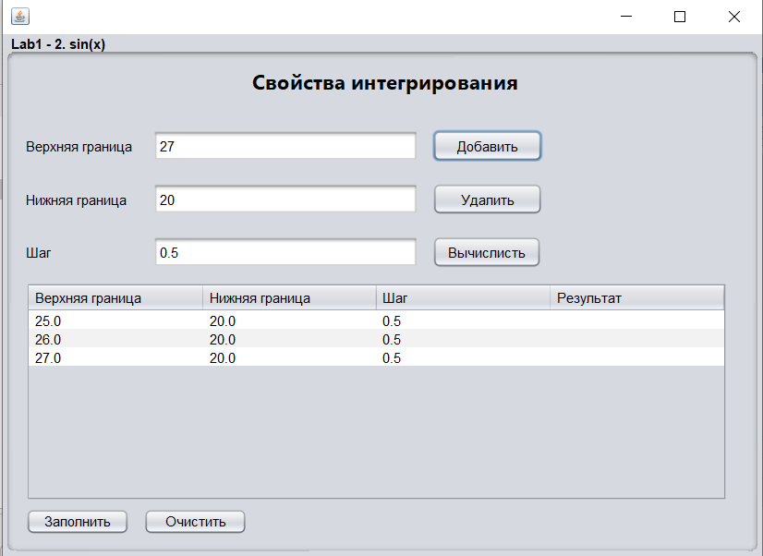

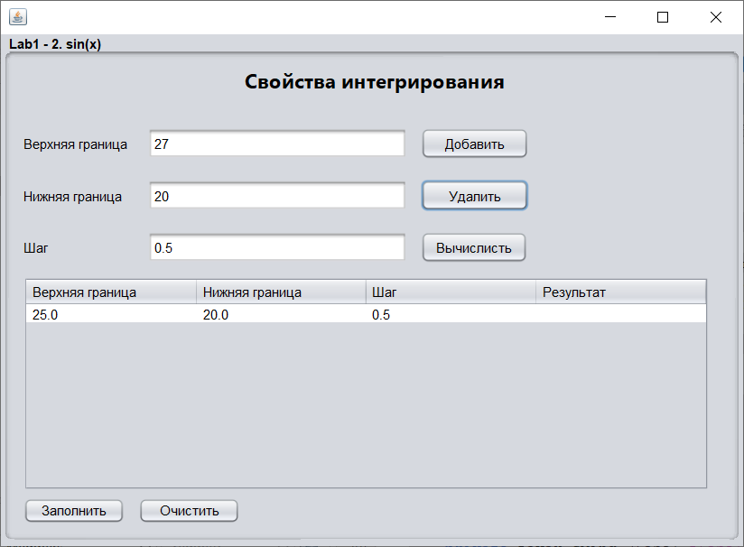

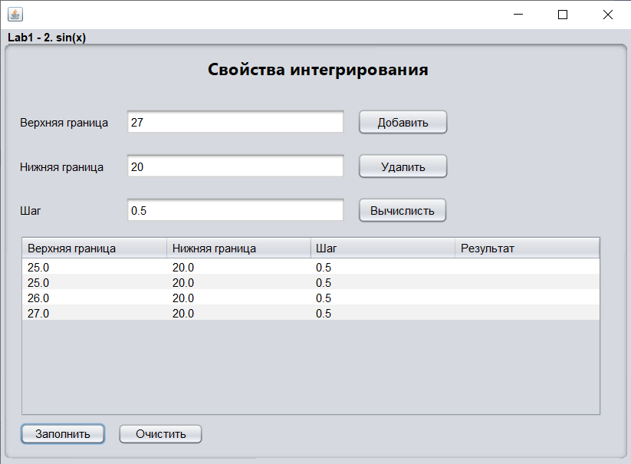

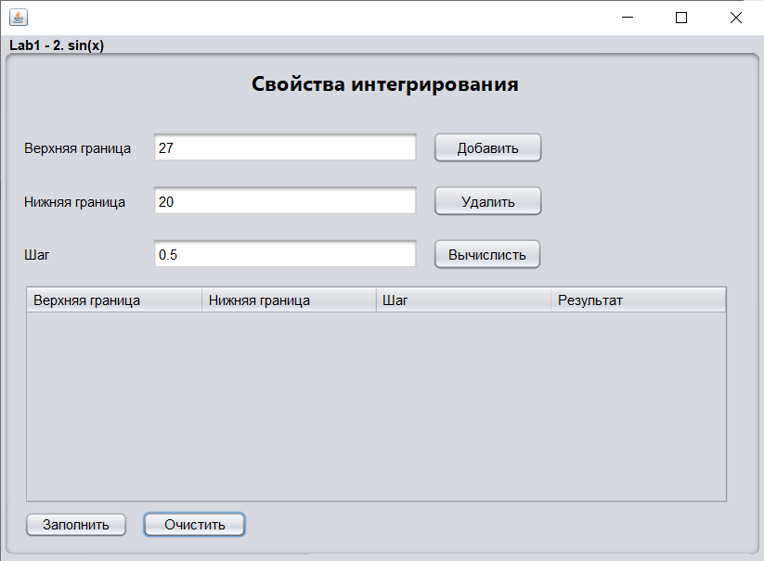

**Выводы:**

В процессе выполнения работы мы изучили библиотеку стандартных коллекций Java Collections Framework, позволяющую хранить различные структуры данных.